 |  |  |  |  | VIKRAM SNEHI  (.NET Core Full stack with Angular & React.js + Azure)
 | +91-7022696667 | connect@snehi.in |  |  |  | vikramsnehi | vsnehi | leetcode.com/u/vikramsnehi  hackerrank.com/vikramsnehi


Proactive and solution-oriented Professional, with a focus on continuous improvement and innovation, targeting challenging assignments as Full Stack Developer with an organization of high repute.

 | Core Competencies  Technical Skills  Certifications  - SQL BASIC, SQL Intermediate, Problem Solving Basic, Problem Solving2, Html from Hacker Rank  - Microsoft Azure Az- 900  - Microsoft Azure AZ-204  - Microsoft Azure AZ-305  Trainings  - Angular, C# .NET, Azure, C & C++ -- NIIT  - .Net Core - KVCH  Internship  - 6 Months .Net – Ibm-Kvch  (06/2018-01/2019)  - 6 Weeks Internship – Mta India  - 6 Weeks Cloud Computing –Kvch  (03/2016)  Education  Personal Projects  - Crime Control System | ASP.NET MVC (04/2020)  - Video Interview System | ASP.NET with React  - Tour & Travel | ASP.NET Web Form  - GitHub (https://github.com/vsnehi)  Personal Details |  |  |  | Profile Summary  - A goal-oriented professional with over 7.4+ years of experience in full SDLC delivery, cloud deployment, & Agile-Scrum, developing scalable, high-performance applications from scratch, spanning finance, gaming, and public service domains.  - Completed EY, successfully completed 4 full-cycle projects (2 back-end in .NET Core, two frontends in Angular) as the sole developer from scratch and 4th project completed in Feb 2026.  - Recently honored with Business Extra Ordinary Award 2025 – EY  - Strong experience in end-to-end design and development of enterprise web applications using .NET Core 8/ 10, C#, Kafka, RabbitMQ, Data Structure & Algorithms, Angular (8–21), React.js, Node.js, SQL Server, Azure DevOps, REST APIs, Python and WPF across diverse client environments including EY, Microsoft, SEI, Light & Wonder, and NSW Government (Australia).  - Designed and delivered scalable .NET and Angular applications, REST APIs, microservices and cloud-native solutions on Azure  - Rich proficiency in designing, developing, and optimizing RESTful APIs, enhancing back-end efficiency and maintainability, Event Driven Application, Microservices Architecture.  - Ensured code quality and system reliability through clean coding practices, peer reviews, debugging, and performance optimization, driving continuous improvement in existing software products.  - Significant experience of working with clients and technical teams for executing projects with focus on project coordination, documentation, business reviews and presentation.  Career Timeline  2023-24  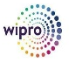    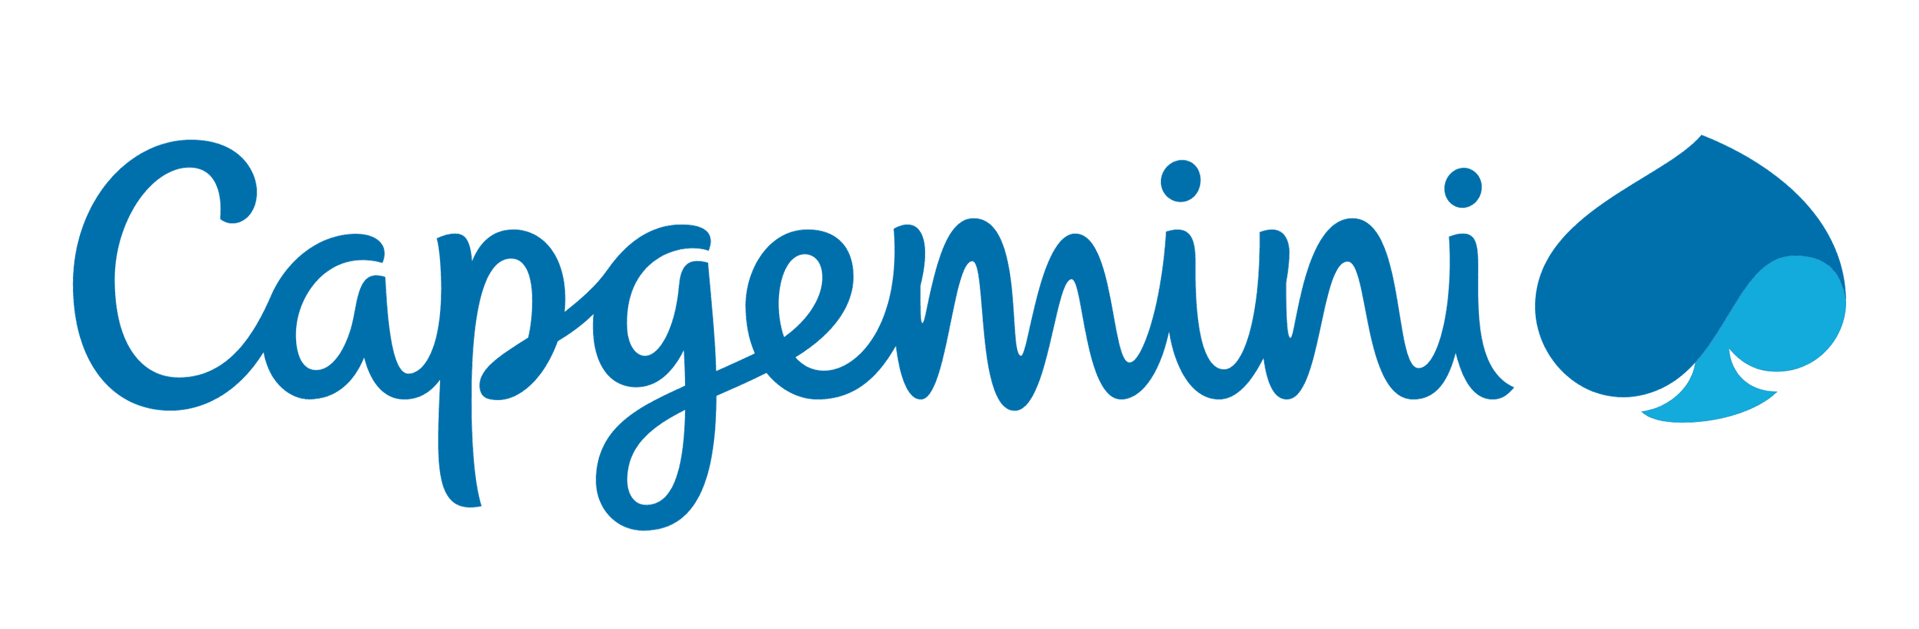      2022-23  2019-22  2024-26  2010-12  Work Experience  Ernest & Young (.NET Core 8/10 Full Stack & Angular 20) Aug’ 24 – May’26  Project: Enterprise Application Platform | Client: Schlumberger  (AEGIS Framework, SRAP, HR-ROFO, MATERIAL ADVISOR)  Responsibilities:  - Implementing authentication, authorization, and role-based access control (RBAC) to ensure secure application access.  - Experienced in working with asynchronous messaging systems such as Kafka and RabbitMQ for reliable communication between distributed services, and Microservices Architecture  - Utilizing Azure DevOps for CI/CD pipeline setup and automated deployment processes.  - Improving system performance and scalability through lazy loading, caching mechanisms, and code optimization techniques.  - Actively contributing within an Agile-Scrum environment to ensure timely and high-quality project deliveries.  - Driving efforts towards maintaining software development practices; adhered to company standards for coding and unit/functional test coverage.; developed / reviewed test cases for conducting Unit & System Integration Testing.  - Mapping requirements of clients as well as different Service Providers, Senior Management, Vendors / Consultants & other Stakeholders for ensuring effective translation of business needs into technology requirements in adherence with company’s objectives.  Highlights:  - Developed the AEGIS framework, a unified platform leveraged across multiple applications—including SRAP, HR-ROFO, and Material Advisor, ensuring scalability, reusability, and streamlined integration across projects.  - Delivered 4 end-to-end projects from the ground up using Angular 19/ 21 and React.js for the frontend and .NET API, Azure, Data Structure & Algorithms, Python for backend development.  - Developed dynamic and responsive user interfaces leveraging Angular, RxJS, HTML, CSS, and JavaScript and AI Tools (Copilot & Cloude)  Capgemini India as (.NET Core 6 Full Stack with Angular) Feb’23 – Aug’24  Project: Enterprise Digital | Client: Microsoft  Responsibilities:  - Designed and developed MyHorizon, a model-driven application, completely from scratch.  - Worked with PowerApps, Dynamics 365, HTML, CSS, and JavaScript to build a robust, user-friendly interface.  - Built the backend using C# .NET Core 6 Web API, Azure, RabbitMQ, WPF and the front-end with Angular 18, React.js, leveraging Node.js and JavaScript for seamless integration.  - Utilized technologies including Azure, GIT, JSON, REST API, XML, SQL, Stored Procedures (SPs), and Node.js for development and deployment.  Project: Financial Platform (.NET Full Stack) | Client: SEI Investments  Responsibilities:  - Designed and developed the SEI Investment Homepage application from the ground up.  - Built the UI using Angular 18, implementing Services, Components, Modules, IDS Components, and HighChart.js for interactive data visualization.  - Worked with Microservices, Web APIs, Azure, RabbitMQ, Design Patterns, HTML, CSS, and JavaScript to ensure scalability and performance.  - Utilized tools and technologies such as Postman, Swagger, JSON, REST API, SQL, Stored Procedures, and Node.js for end-to-end application development.  Light & Wonder, Bangalore as (.NET Core 6 Full Stack & ReactJS) Feb’22 – Jan’23  Project: Enterprise Gaming Platform  Responsibilities:  - Implemented functional code fixes and new feature enhancements using ASP.NET, .NET Core, Angular, Entity Framework, and Node.js.  - Worked extensively with MS SQL Server, Kafka, WPF, including Stored Procedures & database management.  - Developed applications following Azure, Microservice Architecture, MVC, Data Structure & Algorithms, and SOLID principles, applying Factory and Repository Design Patterns for clean, maintainable code.  - Built front-end components with ReactJS, developed backend logic in C#, and integrated multiple REST APIs for seamless data flow.  - Used Bitbucket for version control and collaborative development.  Wipro Limited, Bangalore as (ASP.NET / .NET Core 3) Developer) Feb’19 – Mar’22  Project: Government Digital Transformation Platform | Client: NSW Government, Australia  Responsibilities:  - Migrated Multiple Application to Azure Kubernetes using DevOps CI/CD  - Diagnosed and resolved critical production issues by analyzing error logs, ensuring seamless product rollouts for the client using C#.  - Worked extensively with SQL, Kafka, C#, WPF, Data Structure & Algorithms, .NET MVC, Python, and LINQ ORM for application development and data management.  - Designed and developed enterprise-level applications leveraging RESTful Web Services, Microservices Architecture, and established Design Patterns.  - Built and maintained web solutions using Azure, .NET Core, Angular 8, HTML, CSS, jQuery, and Node.js.  - Applied comprehensive knowledge of the Software Development Life Cycle (SDLC), exhibiting strong technical leadership within Agile-Scrum frameworks.  Achievements:  - Delivered Multiple Enterprise Application from scratch.  - Designed reusable enterprise framework  - Recognized with Business Extraordinary Awards (EY)
  Category | Tools / Technologies
  Front-end Technologies | Angular 20, jQuery, RxJS, Bootstrap, HTML
  Back-end Technologies | .NET Core, ASP.NET, .NET MVC, Microservices, REST API, Entity Framework (ADO)
  DevOps /  CI-CD | CI/CD Pipelines, Azure DevOps
  Database & Data Management | MS SQL Server, NoSQL
  Architecture & Design | Design Patterns, Data Algorithms
  B. Tech. in Computer Science
  Guru Nanak Dev Engineering College, Ludhiana
  Punjab Technical University
  2014-2018
  Address | : INDIA
  Date of Birth | : 25th June 1996
  Languages Known | : English, Hindi

